| **Table 1.** Descriptive statistics. | | | | | |
| --- | --- | --- | --- | --- | --- |
|  | **Total**  (N=366) | **Cohort 1**  (N=62) | **Cohort 2**  (N=110) | **Cohort 3**  (N=116) | **Cohort 4**  (N=78) |
| **Median age in years**  (Q1, Q3) | 56.0  (42.0, 69.0) | 58.0  (46.2, 72.0) | 56.0  (40.0, 66.8) | 60.0  (48.0, 73.0) | 52.0  (40.0, 61.8) |
| **Sex (males)** | 117 (32.0%) | 25 (40.3%) | 52 (47.3%) | 31 (26.7%) | 9 (11.5%) |
| **PTH at baseline** |  |  |  |  |  |
| Mean (SD) | 4.4 (2.3) | 4.5 (2.1) | 3.1 (1.9) | 4.7 (1.7) | 5.6 (3.0) |
| Median (Q1, Q3) | 4.0 (2.7, 5.5) | 4.2 (3.2, 5.2) | 2.5 (2.0, 3.7) | 4.6 (3.7, 5.5) | 5.3 (3.6, 7.2) |
| Min - Max | 0.3 - 15.9 | 1.0 - 13.8 | 0.5 - 13.0 | 1.1 - 10.8 | 0.3 - 15.9 |
| Missing | 19 (5.2%) | 0 (0.0%) | 6 (1.6%) | 4 (1.1%) | 9 (2.5%) |
| **Calcium at baseline** |  |  |  |  |  |
| Mean (SD) | 2.4 (0.1) | 2.4 (0.1) | 2.4 (0.1) | 2.4 (0.1) | 2.3 (0.1) |
| Median (Q1, Q3) | 2.4 (2.3, 2.4) | 2.4 (2.3, 2.5) | 2.4 (2.3, 2.4) | 2.4 (2.3, 2.4) | 2.4 (2.2, 2.4) |
| Min - Max | 2.1 - 3.0 | 2.1 - 3.0 | 2.2 - 2.7 | 2.1 - 2.6 | 2.1 - 2.6 |
| Missing | 25 (6.8%) | 0 (0.0%) | 3 (0.8%) | 6 (1.6%) | 16 (4.4%) |
| **Albumin at baseline** |  |  |  |  |  |
| Mean (SD) | 42.8 (4.2) | 43.3 (3.9) | 42.7 (4.5) | 44.3 (3.2) | 39.8 (3.9) |
| Median (Q1, Q3) | 43.0 (40.0, 46.0) | 44.0 (41.0, 46.0) | 44.0 (40.0, 46.0) | 44.0 (42.0, 47.0) | 39.0 (37.5, 43.0) |
| Min - Max | 30.0 - 51.0 | 35.0 - 51.0 | 30.0 - 51.0 | 35.0 - 51.0 | 31.0 - 49.0 |
| Missing | 20 (5.5%) | 0 (0.0%) | 3 (0.8%) | 6 (1.6%) | 11 (3.0%) |
| **Corrected calcium at baseline** |  |  |  |  |  |
| Mean (SD) | 2.2 (0.1) | 2.3 (0.1) | 2.3 (0.1) | 2.2 (0.1) | 2.2 (0.1) |
| Median (Q1, Q3) | 2.2 (2.2, 2.3) | 2.3 (2.2, 2.3) | 2.2 (2.2, 2.3) | 2.2 (2.1, 2.2) | 2.2 (2.2, 2.3) |
| Min - Max | 2.0 - 2.8 | 2.1 - 2.8 | 2.0 - 2.7 | 2.0 - 2.4 | 2.0 - 2.5 |
| Missing | 27 (7.4%) | 0 (0.0%) | 3 (0.8%) | 6 (1.6%) | 18 (4.9%) |
| **Surgery type** |  |  |  |  |  |
| Completion | 74 (20.2%) | 11 (17.7%) | 15 (13.6%) | 23 (19.8%) | 25 (32.1%) |
| Total | 292 (79.8%) | 51 (82.3%) | 95 (86.4%) | 93 (80.2%) | 53 (67.9%) |
| **Central LND = “Yes”** | 112 (31.2%) | 17 (27.4%) | 57 (52.8%) | 33 (29.2%) | 5 (6.6%) |
| Missing | 7 (1.9%) | 0 (0.0%) | 2 (1.8%) | 3 (2.6%) | 2 (2.6%) |
| **No parathyroid gland seen during surgery** | 48 (13.8%) | 3 (4.8%) | 9 (8.5%) | 20 (18.9%) | 16 (21.9%) |
| Missing | 19 (5.2%) | 0 (0.0%) | 4 (3.6%) | 10 (8.6%) | 5 (6.4%) |
| **PTH at 24 hours** |  |  |  |  |  |
| Mean (SD) | 1.7 (1.3) | 1.8 (1.3) | 1.2 (1.0) | 1.7 (1.2) | 2.2 (1.7) |
| Median (Q1, Q3) | 1.4 (0.5, 2.4) | 1.6 (0.7, 2.7) | 1.1 (0.5, 1.6) | 1.5 (0.6, 2.6) | 2.1 (0.6, 3.3) |
| Min - Max | 0.1 - 8.0 | 0.1 - 5.4 | 0.1 - 4.5 | 0.4 - 4.9 | 0.3 - 8.0 |
| Missing | 28 (7.7%) | 0 (0.0%) | 7 (1.9%) | 11 (3.0%) | 10 (2.7%) |
| **ΔPTH** |  |  |  |  |  |
| Mean (SD) | 55.4 (38.0) | 53.6 (44.0) | 53.4 (45.8) | 59.6 (28.6) | 53.3 (30.9) |
| Median (Q1, Q3) | 60.4 (35.9, 84.7) | 61.8 (30.2, 84.4) | 61.0 (38.9, 86.1) | 64.3 (36.0, 85.2) | 58.1 (38.4, 79.4) |
| Min - Max | -220.0 - 98.4 | -171.4 - 98.0 | -220.0 - 98.4 | -17.4 - 96.3 | -29.2 - 97.0 |
| Missing | 47 (12.8%) | 0 (0.0%) | 13 (3.6%) | 15 (4.1%) | 19 (5.2%) |
| **Albumin at 24 hours** |  |  |  |  |  |
| Mean (SD) | 37.5 (4.8) | 37.2 (3.0) | 37.2 (5.6) | 39.2 (4.7) | 35.8 (4.0) |
| Median (Q1, Q3) | 38.0 (35.0, 40.0) | 37.0 (35.0, 39.0) | 38.0 (35.0, 41.0) | 40.0 (38.0, 41.0) | 36.0 (33.0, 39.0) |
| Min - Max | 0.8 - 48.0 | 31.0 - 48.0 | 0.8 - 46.0 | 2.2 - 47.0 | 27.0 - 45.0 |
| Missing | 14 (3.8%) | 5 (1.4%) | 0 (0.0%) | 7 (1.9%) | 2 (0.5%) |
| **Calcium at 24 hours** |  |  |  |  |  |
| Mean (SD) | 2.1 (0.1) | 2.1 (0.2) | 2.1 (0.1) | 2.1 (0.1) | 2.1 (0.2) |
| Median (Q1, Q3) | 2.1 (2.0, 2.2) | 2.1 (2.0, 2.3) | 2.1 (2.0, 2.2) | 2.1 (2.0, 2.2) | 2.1 (2.1, 2.2) |
| Min - Max | 1.7 - 2.6 | 1.8 - 2.4 | 1.7 - 2.6 | 1.7 - 2.5 | 1.7 - 2.4 |
| Missing | 9 (2.5%) | 0 (0.0%) | 0 (0.0%) | 7 (1.9%) | 2 (0.5%) |
| **Corrected calcium at 24 hours** |  |  |  |  |  |
| Mean (SD) | 2.1 (0.2) | 2.1 (0.1) | 2.1 (0.2) | 2.0 (0.1) | 2.1 (0.2) |
| Median (Q1, Q3) | 2.1 (2.0, 2.2) | 2.0 (1.9, 2.2) | 2.1 (2.0, 2.2) | 2.0 (1.9, 2.1) | 2.1 (2.0, 2.2) |
| Min - Max | 1.6 - 2.7 | 1.7 - 2.4 | 1.7 - 2.7 | 1.7 - 2.7 | 1.6 - 2.4 |
| Missing | 14 (3.8%) | 5 (1.4%) | 0 (0.0%) | 7 (1.9%) | 2 (0.5%) |
| **ΔCorrected calcium** |  |  |  |  |  |
| Mean (SD) | 7.6 (6.5) | 8.6 (6.6) | 7.9 (6.5) | 7.6 (6.9) | 6.4 (5.7) |
| Median (Q1, Q3) | 7.3 (4.1, 11.7) | 8.3 (4.5, 12.6) | 8.2 (4.7, 11.5) | 7.6 (4.2, 12.1) | 6.1 (3.0, 9.1) |
| Min - Max | -29.8 - 23.1 | -6.0 - 23.1 | -27.7 - 21.0 | -29.8 - 22.5 | -5.5 - 18.0 |
| Missing | 33 (9.0%) | 5 (1.4%) | 3 (0.8%) | 7 (1.9%) | 18 (4.9%) |
| **ΔCalcium** |  |  |  |  |  |
| Mean (SD) | 10.6 (6.2) | 11.7 (7.2) | 11.0 (6.0) | 10.6 (6.1) | 9.1 (5.6) |
| Median (Q1, Q3) | 10.1 (6.7, 14.2) | 11.7 (6.7, 17.0) | 10.8 (8.1, 14.5) | 10.0 (6.7, 13.8) | 8.9 (6.3, 12.4) |
| Min - Max | -8.4 - 27.0 | -8.4 - 27.0 | -3.5 - 25.1 | -3.4 - 25.7 | -6.6 - 22.1 |
| Missing | 26 (7.1%) | 0 (0.0%) | 3 (0.8%) | 7 (1.9%) | 16 (4.4%) |
| **Readmissions related to hypocalcemia** | 27 (7.4%) | 3 (4.8%) | 9 (8.2%) | 5 (4.3%) | 10 (12.8%) |
| **Long-term hypoparathyroidism** | 44 (12.0%) | 12 (19.4%) | 9 (8.2%) | 15 (12.9%) | 8 (10.3%) |
| Abbreviations: PTH, parathyroid hormone; ΔPTH, (PTH at baseline - postoperative PTH after 24 hours) / (PTH at baseline) x 100%; Corrected calcium, measured calcium (mmol/L) + 0.016 x (34 - albumin (g/L)); ΔCorrected calcium, (corrected calcium at baseline – postoperative corrected calcium after 24 hours) / (corrected calcium at baseline) x 100%; ΔCalcium, (calcium at baseline – postoperative calcium after 24 hours) / (calcium at baseline) x 100%; LND, lymph node dissection. | | | | | |

|  |  |  |  |  |  |  |  |  |  |
| --- | --- | --- | --- | --- | --- | --- | --- | --- | --- |
| **Table 2.** Full, final, and simple model predicting hypoparathyroidism with a uniform shrinkage factor of 0.868. | | | | | | | | | |
|  | **Full model** | | | **Final model** | | | **Simple model** | | |
|  | OR | 95% CI | Imp. | OR | 95% CI | Imp. | OR | 95% CI | Imp. |
| Intercept | 2.48 | [1.80; 3.42] |  | 1.84 | [1.35; 2.51] |  | 0.00 | [0.00; 0.00] |  |
| ΔPTH  (1% increase) | 1.08 | [1.04; 1.12] | 20.6 | 1.08 | [1.05; 1.12] | 22.5 | 1.08 | [1.05; 1.12] | 28.3 |
| Corrected calcium at 24 hours  (0.2 versus 0.1) | 1.47 | [1.13; 1.91] | 8.1 | 1.44 | [1.11; 1.86] | 7.8 |  |  |  |
| Parathyroid gland not seen during surgery | 3.64 | [1.46; 9.09] | 7.7 | 3.90 | [1.62; 9.37] | 9.3 |  |  |  |
| Age in years  (i.q.r. 69 versus 42 years) | 1.14 | [0.62; 2.10] | 0.2 |  |  |  |  |  |  |
| Males versus females | 0.95 | [0.45; 2.01] | 0.0 |  |  |  |  |  |  |
| Completion surgery versus total | 1.47 | [0.44; 4.85] | 0.4 |  |  |  |  |  |  |
| Central LND = Yes versus No | 1.33 | [0.62; 2.85] | 0.5 |  |  |  |  |  |  |
| *C-index\** | 0.88 | [0.85; 0.92] |  | 0.88 | [0.84; 0.92] |  | 0.85 | [0.81; 0.89] |  |
| Table displays odds ratios and the 95% confidence intervals of the logistic regression model predicting the probability of hypoparathyroidism. The final model is selected using backward selection with p-values < 0.05. The coefficients are averaged over the ten imputed data sets.  *The C-index is corrected for optimism by bootstrapping. Abbreviations: OR, odds ratio; CI, confidence interval, Imp., importance defined by the Chi-square of the Wald-statistic; PTH, parathyroid hormone; ΔPTH, (PTH at baseline - postoperative PTH after 24 hours) /(PTH at baseline) x 100%; Corrected calcium, measured calcium (mmol/L) + 0.016 x (34 - albumin (g/L)); LND, lymph node dissection. | | | | | | | | | |

|  |  |  |  |
| --- | --- | --- | --- |
| **Table 3.** Predictions of hypothyroidism and readmission for all patients. | | | |
|  | Predicted probability of hypoparathyroidism | | |
|  | **Low-risk**  (p < 10%)  n=228 | **Medium risk**  (10% ≤ p ≤ 30%)  n=75 | **High risk**  (p > 30%)  n=63 |
| Long-term hypoparathyroidism | X | X | X |
| No long-term hypoparathyroidism | X | X | X |
| Readmission | 2 (0.9%) | 7 (9.3%) | 18 (28.6%) |
| No readmission | 226 (91.1%) | 68 (90.7%) | 45 (71.4%) |
| The predictions are averaged over the ten imputed data sets. | | | |

**Figure 1.** Patient enrollment process flowchart.

**Identification**

1280 patients with total or completion thyroidectomy identified

897 patients excluded due to ineligibility

* no PTH measurements
* less than one year follow-up

**Screening**

17 patients excluded based on exclusion criteria

* 16 patients with central lymph node dissection within one year
* 1 patients with external neck radiation within one year

383 eligible patients

**Included**

**366 patients included**

**Figure 2.** Internal-external model performance of the final model without shrinkage on one single imputed data set.

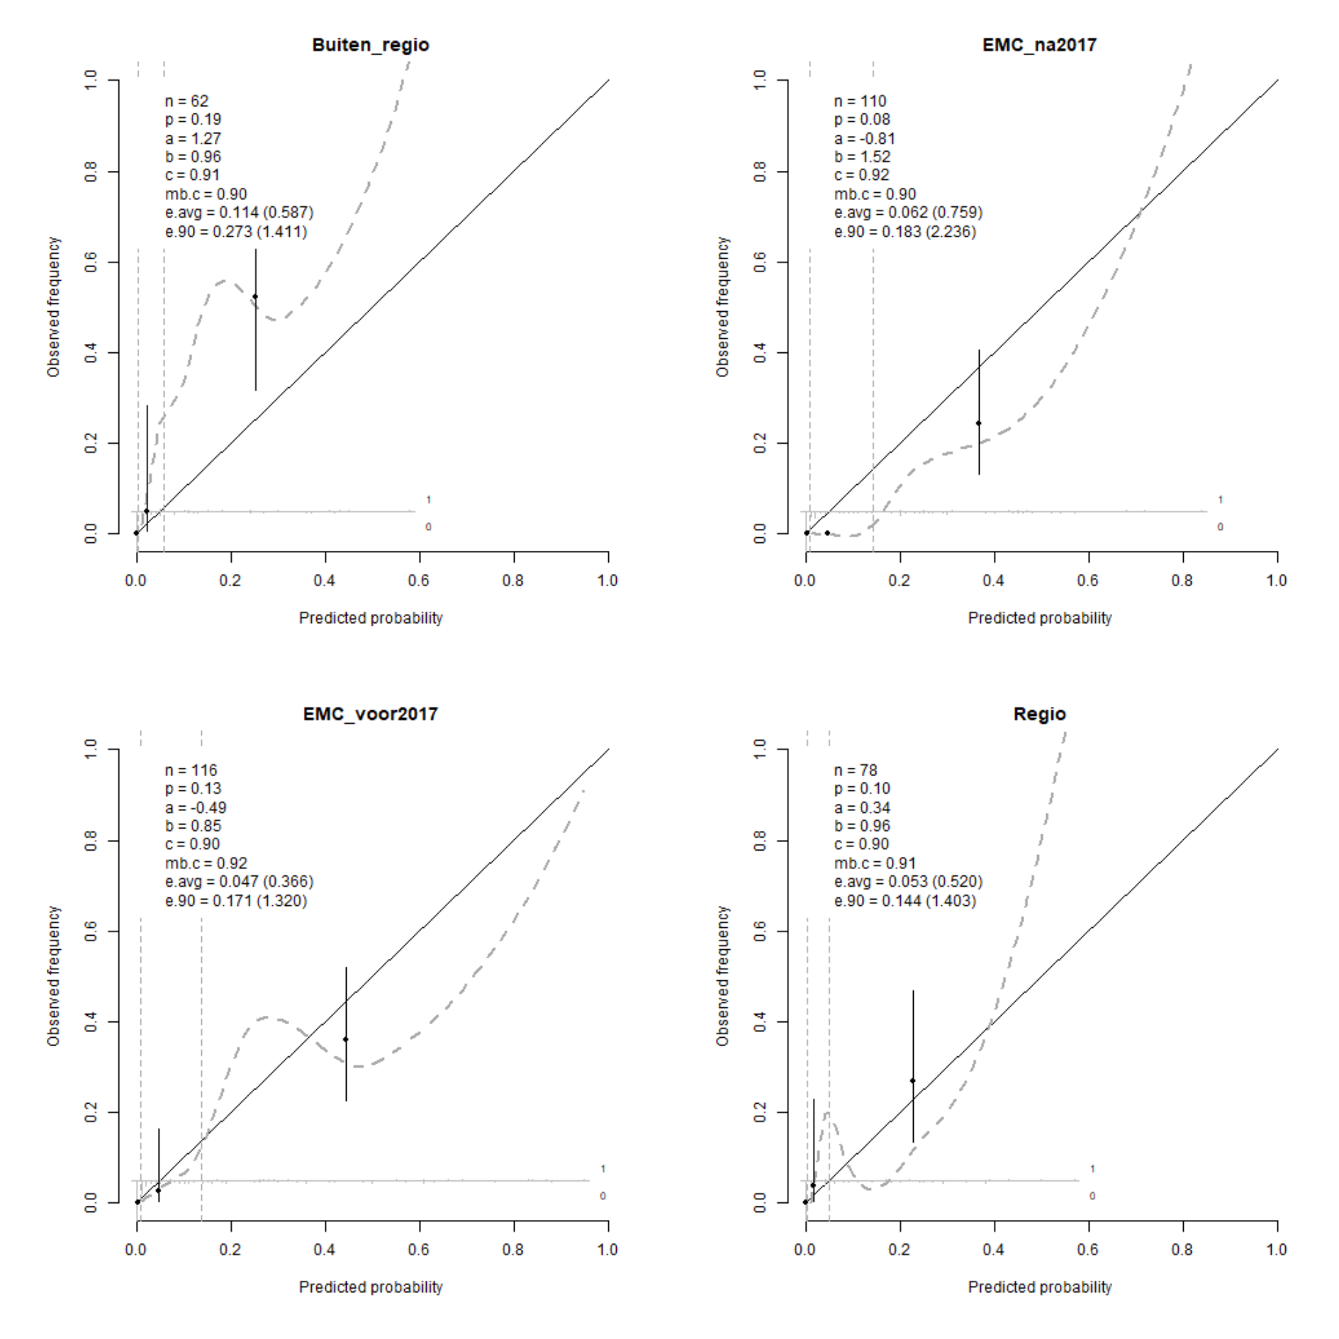

**Figure 3.** Proposed use of prediction model in clinical practice

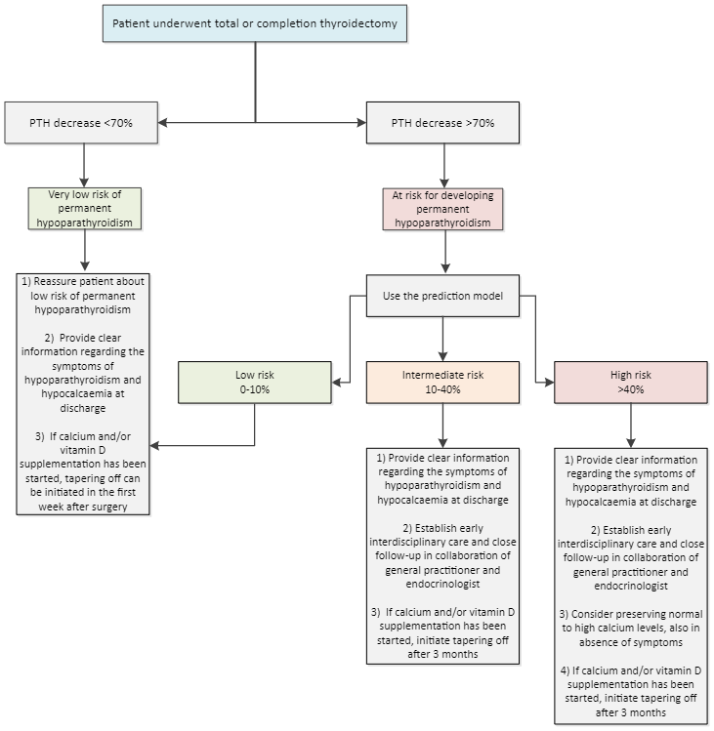

**Supplemental table 1. Comparison of functional form of PTH and calcium in the full model without shrinkage in one single imputed data set.**

|  |  |  |
| --- | --- | --- |
| Functional form of PTH | Functional form of Calcium | AIC |
| PTH24u | Ca24u | 205.9 |
| PTH24u | CorrCa24u | 200.7 |
| PTH24u | ΔCa | 211.1 |
| PTH24u | ΔCorrCa | 207.9 |
| ΔPTH | Ca24u | 186.7 |
| **ΔPTH** | **CorrCa24u** | **182.7** |
| ΔPTH | ΔCa | 190.4 |
| ΔPTH | ΔCorrCa | 188.3 |

**Supplemental table 2. Flexibility of ΔPTH, calcium, and age in the full model without shrinkage in one single imputed data set.**

|  |  |  |  |
| --- | --- | --- | --- |
| ΔPTH | Corrected calcium | Age | AIC |
| ΔPTH | CorrCa24u | Age | 182.7 |
| rcs(ΔPTH, 3) | CorrCa24u | Age | 183.9 |
| **rcs(ΔPTH, 4)** | **CorrCa24u** | **Age** | **182.4** |
| rcs(ΔPTH, 5) | CorrCa24u | Age | 184.9 |
| ΔPTH | rcs(CorrCa24u, 3) | Age | 184.1 |
| ΔPTH | rcs(CorrCa24u, 4) | Age | 185.9 |
| ΔPTH | rcs(CorrCa24u, 5) | Age | 187.6 |
| ΔPTH | CorrCa24u | rcs(Age_Years, 3) | 183.8 |
| ΔPTH | CorrCa24u | rcs(Age_Years, 4) | 185.8 |
| ΔPTH | CorrCa24u | rcs(Age_Years, 5) | 185.0 |
| rcs(ΔPTH, 4) | rcs(CorrCa24u, 3) | Age | 184.1 |
| rcs(ΔPTH, 4) | CorrCa24u | rcs(Age_Years, 3) | 183.7 |
| ΔPTH | rcs(CorrCa24u, 3) | rcs(Age_Years, 3) | 185.1 |
| rcs(ΔPTH, 4) | rcs(CorrCa24u, 3) | rcs(Age_Years, 3) | 185.3 |

Likelihood ratio test of best flexible model versus rigid model $χ^{2}=4.3;p=0.115$.

**Supplemental table 3. $Δ$ PTH and readmission**. ΔPTH is averaged over the ten imputed data sets.

|  |  |  |
| --- | --- | --- |
|  | $Δ$ PTH $≤$ 70% | $Δ$ PTH > 70% |
| No readmission | 23 | 316 |
| Readmission | 0 | 27 |

**Supplemental figure 1. Plot predict of flexible model without shrinkage, i.e., PTH, calcium, and age modelled with restricted cubic splines with three degrees of freedom of one single imputed data set.**

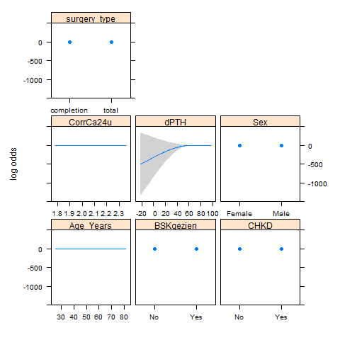

**Supplemental Figure 2. Model performance of models uncorrected for optimism**. The predicted probabilities were averaged over the ten imputed data sets. No shrinkage was applied to the models. There is statistical evidence that the final model is better than the simple model (Likelihood ratio test $χ^{2}=19.0;p<0.001$). There is no statistical evidence that the full model is better than the final model, therefore we choose the sparse model (Likelihood ratio test $χ^{2}=1.1;p<0.892$).

|  |  |
| --- | --- |
| Full model | Final model |
| Z:\Project Predict Hypoparathyroidism\Development\Results\model.performance.full.model.png | Z:\Project Predict Hypoparathyroidism\Development\Results\model.performance.final.model.png |
| Simple model |  |
| Z:\Project Predict Hypoparathyroidism\Development\Results\model.performance.simple.model.png |  |

**Supplemental Figure 3**

**Functional form of full model**

$$\log\left(\frac{p_{i}}{1-p_{i}}\right)=β_{0} \\ +β_{1}⋅ΔPTH \\ +β_{2}⋅Parathyroid gland not seen \\ +β_{3}⋅Corrected calcium at 24 hours \\ +β_{3}⋅Age \\ +β_{4}⋅Male \\ +β_{5}⋅Completion surgery \\ +β_{6}⋅Cenral LND$$

Abbreviations: ΔPTH, (PTH at baseline - postoperative PTH after 24 hours) /(PTH at baseline) x 100%; Corrected calcium, measured calcium (mmol/L) + 0.016 x (34 - albumin (g/L)); LND, lymph node dissection.

**Functional form of final model without shrinkage**

$$\log\left(\frac{p_{i}}{1-p_{i}}\right)=β_{0} \\ +β_{1}⋅ΔPTH \\ +β_{2}⋅Parathyroid gland not seen \\ +β_{3}⋅Corrected calcium at 24 hours$$

Abbreviations: ΔPTH, (PTH at baseline - postoperative PTH after 24 hours) /(PTH at baseline) x 100%; Corrected calcium, measured calcium (mmol/L) + 0.016 x (34 - albumin (g/L)); LND, lymph node dissection.